# Mini-Project (Part 1)

## Parameters (default in code):

* pRE = 1000
* pIM = 1000
* iterations = 100
* threshold = 2
* Chunk Size Range = (1 to 200, step 10)

## Performance Comparison

**Computation specs:**

* Intel® Core™ i5-11300H-processor

|  |  |  |
| --- | --- | --- |
| **Algorithm** | **Script location (root)** | **Computation Time (s)** |
| Naive | *mandelbrot_naive.py* | 3.91s |
| Numpy vectorized | *mandelbrot_numpy.py* | 2.12s |
| Numba-optimized | *mandelbrot_numba.py* | 1.39s |
| Multiprocessing | *mandelbrot_multicore.py* | 1.23s |

## Analysis of Multiprocessing Implementation

**The 10 best performance results for different chunk sizes and processor amount**

*(See Computations.xlsx, Sheet: “Best Runs”)*

|  |  |  |  |
| --- | --- | --- | --- |
| **#Rank** | **Number of processors** | **Chunk Size** | **Computation Time (s)** |
| 1 | 4 | 81 | 1.22848 |
| 2 | 4 | 121 | 1.22871 |
| 3 | 4 | 41 | 1.2295 |
| 4 | 4 | 131 | 1.23295 |
| 5 | 4 | 51 | 1.23985 |
| 6 | 4 | 61 | 1.24845 |
| 7 | 5 | 101 | 1.2581 |
| 8 | 4 | 91 | 1.25935 |
| 9 | 5 | 51 | 1.26235 |
| 10 | 5 | 21 | 1.26936 |

**Optimal chunk size in relation to number of processes based on computation time:**

*(See Computations.xlsx, Sheet: “Optimal chunk size for core”)*

**Gradient of computation time across parameters**

*(Graph is computed after running “mandelbrot_multicore.py”)*

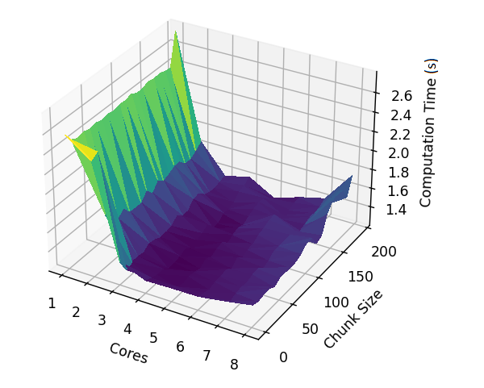

*(See Computations.xlsx, Sheet: “Chunk Size”)*

**Speedup, Efficiency and Overhead across number of cores***(See Computations.xlsx, Sheet: “Speedup”)*

**Speedup for chunksize***(See Computations.xlsx, Sheet: “Speedup”)*

*(See Computations.xlsx, Sheet: “Core 201 chunk size”)*

**Output from running algorithm**

